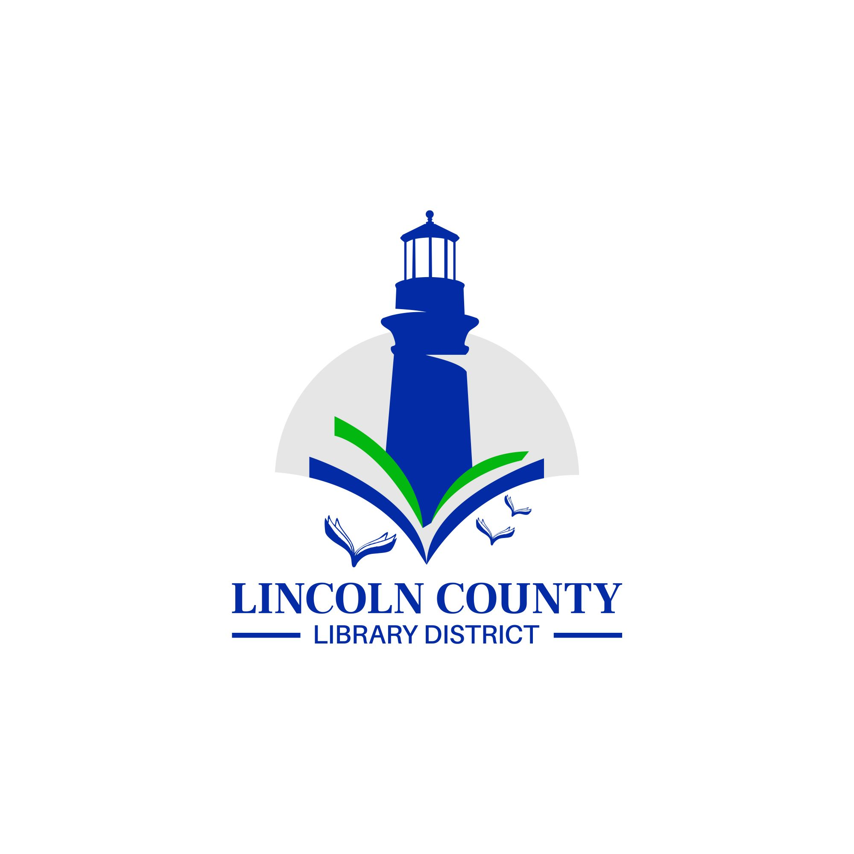
Minutes
Lincoln County Library District
Board Meeting
October 11, 2022
12:00 p.m.
Zoom

ATTENDANCE—BOARD
Chris Boyle
Virginia Tardaewether
Carla Clark
Susan Garner

ATTENDANCE—STAFF
MaryKay Dahlgreen, District Director

CALL TO ORDER
Chris Boyle called the Regular Board Meeting to order at 12:00 p.m.

CALL THE ROLL AND ESTABLISH QUORUM
Quorum was established.

PUBLIC COMMENT

APPROVAL OF MEETING MINUTES
Virginia moved and Susan seconded approval of the Regular Board minutes of September 13, 2022. Passed unanimously.

BOARD MEMBER REPORTS
MaryKay thanked Carla for trying to attend the Siletz City Council meeting on October 10, 2022 that had apparently been cancelled.

DIRECTOR’S REPORT
MaryKay attended the SDAO Summer Conference and Awards Banquet on Thursday September 15, 2022. In addition to attending the SDAO Board meeting, she attended sessions on Recruiting and Retaining Employees and Liability Determination. Both were very valuable.

On Friday September 23, 2022 MaryKay visited Crestview Heights School to talk about library card sign-up month and read stories. She will go back in October to meet the rest of the classes. She was hosted by the school librarian, Harris.

MaryKay met Traci Altson-Miller, new library administrator of the Yachats Public Library and Michelle Cottrell, new district media specialist at the Lincoln County School District. Both were invited to the Tuesday morning library directors meeting and attended on October 4, 2022. We are looking forward to collaborating with both.

The feasibility study that has been conducted by Carson Block, using an LSTA Grant from the State Library of Oregon, has been completed. The report will be distributed to our partners and Carson will make a virtual presentation to the LCLD Board at their November 8, 2022 meeting.

Lincoln County Reads 2022 is underway and will culminate in two virtual programs on October 16th. The author, Silvia Moreno-Garcia will be interviewed in Spanish by Driftwood PL outreach coordinator, Star Khan, and then Silvia will give a presentation about the book we are reading, Mexican Gothic. Registration information is available for both programs on the LCLD website.

The Rotary Social has been scheduled for November 9th at 5:15 p.m. at the LCLD office. MaryKay will use LCLD funds for catering but not for alcohol. If Board members would like to donate beer or wine that would be great, but shouldn’t feel obligated.

FINANCIAL REPORT
MaryKay didn’t get the September report in the Board packet but will include it in the November Board packet along with the October report.

OLD BUSINESS
Building Purchase Update
Still waiting. MaryKay checks in with Ron on a regular basis and he is waiting

Library Service Agreements Update
Two have been signed, Lincoln City and Siletz. The other three are pending.

OLD BUSINESS
Policy Approval
Last month, the Circulation Policy draft, Patron Confidentiality Policy draft, Unattended Children Policy draft, and an Object Donation form draft were introduced. Virginia moved and Carla seconded approval of the policies. Passed unanimously.

Bylaws Draft Review
At the July 2022 meeting the Board decided to change the Treasurer position to a Vice-President position since there really isn’t a need for a treasurer. A draft with those changes was presented to the Board at the September meeting. Virginia moved and Susan seconded approval of the bylaws. Passed unanimously.

NEW BUSINESS
Paid Leave Oregon
MaryKay introduced a new mandatory State of Oregon program that will take effect in 2023 that will provide up to 12 weeks of paid leave for a variety of situations for Oregonians. Since LCLD has fewer than 25 employees we don’t need to contribute but if we do we will be eligible for grants to backfill employees on paid leave.

GOOD OF THE ORDER

NEXT DISTRICT MEETING
The next regular meeting of the LCLD Board will be held on Tuesday November 8, 2022 at noon at the LCLD office and on zoom.

ADJOURNMENT
Meeting adjourned at 12:40 p.m.

