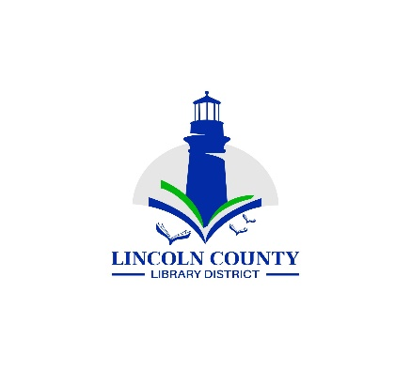
Lincoln County Library District Board Meeting
Wednesday April 10, 2024
Siletz Public Library
255 SE Gaither St., Siletz, OR 97380

Agenda
Call Regular Meeting to Order |  | President
Approval of the Agenda |  | President
Topic | Lead |  | Purpose Outcome
Public Comment | President |  | Anyone may speak at this time
Minutes  Board Meeting  February 14 2024 | President |  | Approval
Reports
Board Reports | Board Members |  | Information
Director’s Report | Director |  | Information
Financial Report | Director |  | Acceptance
Old Business
New Business
Insurance increases for 2024-25FY | Director |  | Information
Technical Services Specialist offers | Director |  | discussion
Next District Board Meeting  May 8, 2024 |  |  | Information

